Modified Constraint-Induced Movement Therapy (mCIMT) Program

Participant Workbook

Program dates:

Participant Name:

This workbook was developed by the following occupational therapist to help other therapists to prepare for, and conduct a 2-week CIMT program. The workbook may be adapted for use, and used free of charge, provided the information below is not removed:

Louise Massie, Occupational Therapist, Shoalhaven District Memorial Hospital, Nowra, NSW, Australia (louise.massie@sesiahs.health.nsw.gov.au)
Gillian Gibson, Senior Occupational Therapist, Stroke Outreach Service, Royal Prince Alfred Hospital, Sydney Local Health District, Camperdown, NSW, Australia (Gillian.gibson@sswahs.health.nsw.gov.au)
Ana Vandenberg, Senior Occupational Therapist, Outpatient Rehabilitation Service, Launceston General Hospital, Tasmania, Australia (ana.vandenberg@dhhs.tas.gov.au)
Dr Annie McCluskey, Senior Lecturer, Discipline of Occupational Therapy, The University of Sydney, Sydney, Australia (annie.mccluskey@sydney.edu.au)

Suggested citation:
Massie, L., Gibson, G., Vandenberg, A., & McCluskey, A. (2014). Modified constraint induced movement therapy (mCIMT) program: Participant workbook. Sydney, Australia.

Acknowledgements:
The following therapists provided valuable information and feedback on program content, and generously shared their resources and knowledge:
Phillip Fay, private occupational therapist, Sydney, AUSTRALIA
Prof Dave Morris, University of Alabama at Birmingham, Alabama USA
Dr Ted Stevenson, physiotherapist, St Boniface Hospital, Winnipeg, CANADA

Table of Contents
Participant details…………………….………………………………………………………………………………..4
My goals for the program……….…………………………………………………………………………………5
Outcome measures……………………………………………………………………………………………………6
Participant Information………………………………………………………………………………………………7
Typical timetable ……….………………………………………………………………………………………………8
Behavioural contract………………….………………………………………………………………………………9
Day 1…………………………………………………………………………………………………………………………12
Time trial recording sheet and graph.………………………………………………………………………. 15
Day 1 Home assignments………………………………………………………………………………………… 16
Day 10 Brainstorm……………………………………………………………………………………………… ……17
Follow-up Measures………………………………………………………………………………………………….18
Examples of shaping activities…………………………………………………………………………………..19
Chinese stress balls……………………..………………………………………………………………………….19
Cocktail sticks………………………………..……………………………………………………………………….20
Playing cards…………………………………..………………………………………………………………………21
Elastic bands around can…………………………………..……………………………………………………22

Participant Details

Name:
Age (years):
Gender:
History of Condition:
Onset (months):
Which side is most affected:
Dominance:
Grade (2-5) / degree of arm/hand movement (shoulder, wrist, fingers and thumb):
Sensation:
Pain:
Mobility:
Communication, vision, hearing and cognition:
Participant contact details:
Address: …………………………………………………..
Phone: …………………………………………………..
Email: …………………………………………………..

Carer details:
Informed consent obtained to participate: Yes No
Medical practitioner contact details {for medical clearance}:

My goals for the program

Goal | COPM Satisfaction |  | COPM Performance
 | (Pre  program score) | (Post program score) | (Pre program score) | (Post program score)
1. EG “To play a season of basketball next year”

2. EG “To hold the ‘shift’ key down with little finger of L hand when typing”

3. EG “to use the clutch on my motorbike”

4. EG “to change my baby’s nappy”

5. EG “to eat using a knife and fork when out at dinner with friends”

Outcome measures
Measure | Baseline |  | Comments | After mCIMT |  | Comments
 | Date | Score |  | Date | Score

9 Hole Peg Test (9HPT) (secs)

Motor Assessment Scale (MAS)

Subtest 6 (0-6)

Subtest 7 (0-6)

Subtest 8 (0-6)

Box and Block Test (blocks in 60 secs)
Motor Activity Log (MAL)  a) AoU (0-5)  b) QoM (0-5) |  |  | Completed? Y/N  Attached? Y / N |  |  | Completed? Y/N  Attached? Y / N
Canadian Occupational Performance Measure (COPM) (0-10) |  |  | Completed? Y/N  Attached? Y/ N |  |  | Completed? Y / N  Attached? Y / N

Participant Information
What is mCIMT?
Constraint-induced movement therapy (CIMT) is an intensive supervised therapy program that improves hand and arm recovery after stroke and acquired brain impairment. The program aims to change your brain (ie neuroplasticity) and explore ways for you to use your stroke-affected hand and arm at home and in everyday tasks much more. We will be providing a modified version (mCIMT), involving fewer hours (3-4 hours instead of 6 hours per day), which has also been shown to be just as effective as the 6 hour program, for rehabilitation of the upper limb. The mCIMT program involves two weeks of intensive training for your stroke-affected hand (like ‘boot camp’), while your ‘good’ arm and hand are placed in a constraint ‘mitt’ (like a vacation for your less affected hand).

What is meant by ‘constraint’?
The ‘constraint’ refers to the padded mitt or glove that you will wear on your good hand, in order to force you to use your stroke-affected hand for all activities. You will be able to put on/take off the ‘mitt’ yourself. You will be required to wear this ‘mitt’ during the program and at home when you are completing your daily home assignments.
How much time is required of me?
The program is time intensive, for you and the therapists supervising the program. You will be asked to use your stroke-affected arm for up to 90% of waking hours, and complete home assignment tasks. Therefore, you and your carer (if relevant) will be asked to sign a ‘behavioural’ contract on Day 1, outlining expectations and responsibilities. You will be required to attend <<insert name of facility>> for 4 hours per day, 5 days per week for 2 weeks and complete up to one hour of daily home assignments. Before the program starts, we will ask you to attend a 2 hour baseline measurement session. These measures of your affected hand and arm will also be repeated (another 2-4 hours) after the program has been completed.

What is the purpose of this workbook?
The workbook will be used to document tasks that you complete while involved in the program. The workbook also provides a place for us to document your arm function at baseline and after you have completed the program, to record changes in use of your arm and hand over the two weeks. You will be given a copy of the workbook to keep when the program finishes, so that you can continue the activities and progress afterwards.
Will there be any cost for the program?
No, there is no cost for attending the mCIMT program but you will be asked to organise your own transport and bring your lunch each day while attending.

Photographs and videos
During your baseline measurement session, we will take some photographs and videos of you performing tasks, which we will use to plan your specific program. We will also show these images to other therapists and any students/volunteers who may be working with you. During the 2-week program, we may also take additional photographs and videos to use for teaching purposes (for example, when conducting workshops for other therapists, or conference presentations). If you do not wish any of these images to be used for teaching purposes, please let us know in advance.

Typical Timetable
Time | Activity
10:00am – 10:30am | Review of home assignments.  10 or 15 questions from Motor Activity Log
10:30am - 11:30am | 6 Timed Trials x 10 reps each (10 mins per task/trial)
11:30am - 12:00md | Task-specific practice of 2-3 tasks related to your goals
12:00md – 12:30pm | 3 different Timed Trials x 10 reps each (10 mins each)
12.30pm-1.00pm | Lunch
1.00pm - 1.50pm | 5 different Timed Trials x 10 reps each (10 mins each)
1.50pm -2.00pm | Plan for home assignments (10 tasks, 5 easy/5 more challenging)

Behavioural Contract

The following contract outlines your responsibilities, those of your carer (if participating) and therapist during the 2-week mCIMT program at <<insert name of facility>>, and at home. The aim is for you to use your more-affected arm as much as possible. While using the more-affected arm as much as possible is desirable, your safety is also important. During the 2 week, you may be asked to complete a task in a way that is different to what you would normally do (eg brushing your teeth with your non-dominant hand) just for the duration of the program (ie not permanently), to encourage recovery of your hand.

For some tasks, you may need help from a carer, which will be preferable to you removing the mitt. We will identify tasks where it is acceptable for your carer to help.

This behavioural contract is a formal agreement between you, the therapy team / service, and your carer. This contract and your responsibilities should be taken seriously. The contract will be signed by you and your carer, and a witness during the first day.

Acknowledgement: Training materials from Prof Dave Morris and staff at UAB, Alabama, USA

Participant Responsibilities:
- Attend assessment before and after the program, all training sessions and one month follow up session.
- Mitt use
  - Wear the ‘mitt’ during all training sessions
  - Wear the ‘mitt’ for approximately of 1 hour at home each evening while completing tasks that require you to use your arm, during the two weeks that you are attending the program
- Keep an accurate training record of repetitions at home
- Organise transport to/from the program
- Arrive on time for the program each day
- Bring your lunch to the program

About the Mitt
I,________________________, agree to wear the mitt on my good arm (i.e., the arm that was not affected by the stroke). I agree to use the arm that was most-affected by the stroke as much as possible when I am away from the therapy sessions. The purpose of the mitt is to prevent me from using my good arm. I agree not to remove the mitt at any time or for any task for which I have agreed to wear it. An exception will be that I will not try to use my more-affected arm alone if my safety might be affected. Safety is always important. Another exception is when a task can only be completed with two hands or when I am using hot water. When possible and necessary, my carer will assist with a task by acting as a ‘second arm’ just as the therapists do during sessions. Tasks that my carer is allowed to help with are marked with a (√) in the carer column.

I will start wearing the mitt when I wake up at about _______ a.m.

Tasks for which I will use my More-Affected Arm Only

I have agreed with my therapist, _________________, that I will make a big effort to use my more-affected arm as much as possible during the tasks listed below, while wearing my mitt on my less-affected arm. The approximate times when I think these tasks are most likely to be carried out are also listed.

A.M. tasks using my more-affected arm only Times Carer Assistance (Y/N)

------------------------------------------------------------- -------- --------------------------

------------------------------------------------------------- -------- --------------------------

------------------------------------------------------------- -------- --------------------------

------------------------------------------------------------- -------- --------------------------

------------------------------------------------------------- -------- --------------------------

P.M. tasks using my more-affected arm only Times Carer Assistance (Y/N)

------------------------------------------------------------ -------- --------------------------

------------------------------------------------------------ -------- --------------------------

------------------------------------------------------------ -------- --------------------------

------------------------------------------------------------ -------- --------------------------

------------------------------------------------------------ -------- --------------------------

Tasks for which I will use BOTH Arms

My therapist …………………………………and I have agreed that I will use both arms for the following tasks either for safety reasons, or because these tasks cannot be done one-handed.

Tasks using BOTH arms Times Carer Assistance (Y/N)

--------------------------------------------------------------- -------- --------------------------

--------------------------------------------------------------- -------- --------------------------

--------------------------------------------------------------- -------- --------------------------

--------------------------------------------------------------- -------- --------------------------

--------------------------------------------------------------- -------- --------------------------
Tasks for which I can remove my mitt

My therapist …………………………………and I have agreed that I can remove the mitt for the following tasks either for safety reasons, or because these tasks cannot be done one-handed.

Time off Less-affected arm only activities Time on

--------------------- ---------------------------------------------------------------- ---------------------

--------------------- ---------------------------------------------------------------- ---------------------

--------------------- ---------------------------------------------------------------- ---------------------

--------------------- ---------------------------------------------------------------- ---------------------

--------------------- ---------------------------------------------------------------- ---------------------

--------------------- ---------------------------------------------------------------- ---------------------

Therapist Responsibilities:

- Provide ‘mitts’ and equipment necessary for the program
- Provide a program of tasks during training sessions
- Provide supervision/instruction/encouragement during the program
- Provide a copy of the workbook and a resource manual on completion of program

________________________________________________________________________________

Signatures:

I understand the above descriptions and agree to comply with listed responsibilities to the best of my ability.

Participant: Date:

Therapist: Date:

Carer: Date

Witness: Date
________________________________________________________________________________

Day 1 <<Insert Day and Date>>
Complete 10 or 15 Motor Activity Log questions (How well scale)
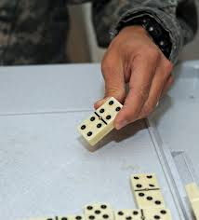
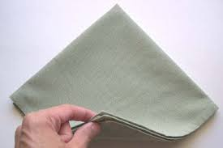
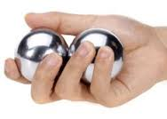
Day 2 onwards: Review home assignments after completing the MAL, before commencing practice
 |  | Task Description/Comments |  | Record reps here
1 HOUR: Timed Trials (30 - 45 secs each, 10 trials + shaping; graph summary feedback; 6 tasks)
Task: |  | Eg Number of dominoes flipped in 30 secs  [OR time taken to flip 8 dominoes]  Total reps for this trial: 58 Best trial: 7 |  | 5, 5, 6, 6, 5, 6, 6,  7, 6, 6
Task: |  | EG Rotations of Chinese Stress Balls x 20  Total reps for this trial: 200 Best trial: 30 secs |  | (secs) 35, 30, 34, 35, 30, 40, 34, 33, 33, 32
Task: |  | EG Folding napkins (time taken to fold 7)  Total reps: 70 Best trial: 36 secs |  | secs) 39, 39, 38, 38, 36, 38, 38, 37, 37, 45
30 MINS: Task-Specific Practice/ Part Practice (3 tasks, goal focused)
Task: |  | EG USE OF ELECTRIC DRILL  - Squeezing handle of laundry bottle and spraying water onto towel x 5  - Pressing button on electric drill with thumb x 2  - Lifting hand up to touch a mark on wall in front (shoulder height) and hold for 5 secs  Total Reps: 90  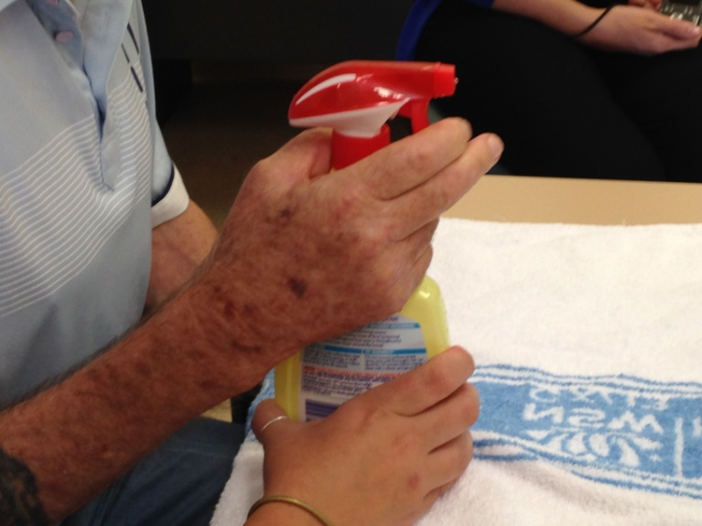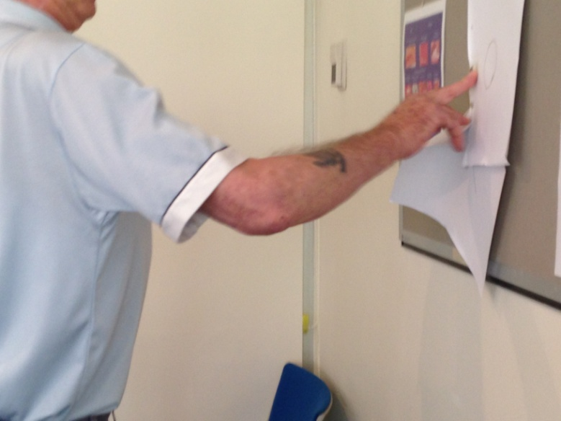 |  | Repetitions:  1). 5, 5, 5, 5, 5  2). 2, 2, 2, 2, 2  3). 1, 1, 1, 1, 1, 1, 1, 1, 1, 1  1). 5, 5, 5, 5, 5  2). 2, 2, 2, 2, 2  3). 1, 1, 1, 1, 1, 1, 1, 1, 1, 1
Task: |  | 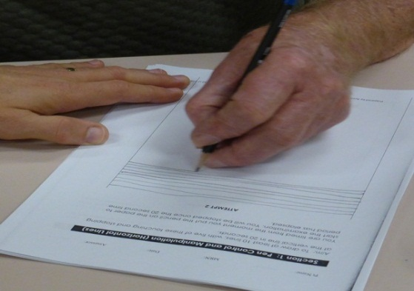  EG HAND WRITING PRACTICE: Write “Stephen Jones, 12 Smith St. BROWNSVILLE NSW 2100 (Record time taken)  Total reps: 7 |  | Repetitions:  15 (secs), 16, 16, 17, 18, 18, 13, 13,
Task: |  | 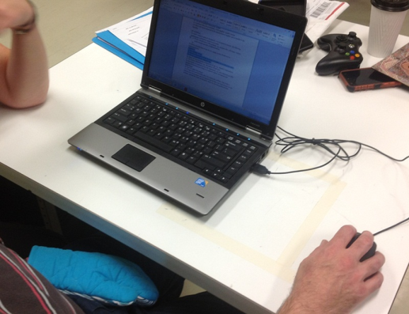  EG USE OF A MOUSE WITH COMPUTER  - Write name with mouse in paint  “Susan Green” (Record time taken) Total reps: 10 |  | Repetitions:(secs)  25, 24, 25, 26, 28, 25, 24, 24, 24, 25
30 MINS: Timed Trials (30 - 45 secs each, 10 trials + shaping; graph summary feedback)
 |  | Task Description/Comments | Record reps here
Task: |  | EG number of cards turned in 30 seconds  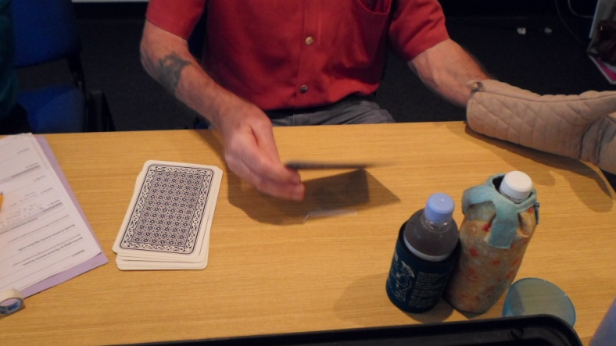  Total reps: 105 Best trial: 12 | 10, 11, 10, 9, 9, 9, 11, 12, 12, 12
Task: |  | EG time taken to pour a glass of water from a jug and then tip the water back into the jug  Total reps: 10 Best trial: 35 sec | (secs)  40, 42, 38, 39, 38, 38, 38, 37, 35, 35
Task: |  | EG time taken to stack 5 plates into dish drainer  Total reps: 50 Best trial: 32 sec 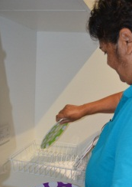 | (secs)  35, 35, 35, 34, 34, 32, 32, 32, 33, 32
30 MINS: Lunch:
What did you eat and drink? EG I opened the container, pulled out the grapes, held my sandwich, open my water bottle and drink from it.
How did you use your arm to make/eat your lunch? EG pulled out the bread, put the ham on the sandwich, pulled the grapes off the stem.
What did you do well? EG holding my sandwich
What was difficult? EG opening my water bottle
45 MINS: Timed Trials (30-45 secs each, 10 trials + shaping; graph summary feedback; 5 tasks)
 | Task Description/Comments |  | Record reps here
Task : | EG flipping ten coins in a row  Total reps: 100 Best trial: 35 sec |  | (secs)  36, 35, 35, 35, 36, 36, 37, 35, 35, 35
Task : | EG putting six pegs on the clothes line  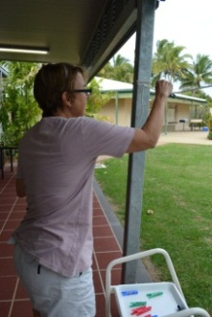  Total reps: 60 Best trial: 42 sec |  | (sec)  45, 45, 44, 44, 43, 42, 42, 42, 42, 42
Task : | EG Wrist extension to a target while holding a cone x 10 reps each trial  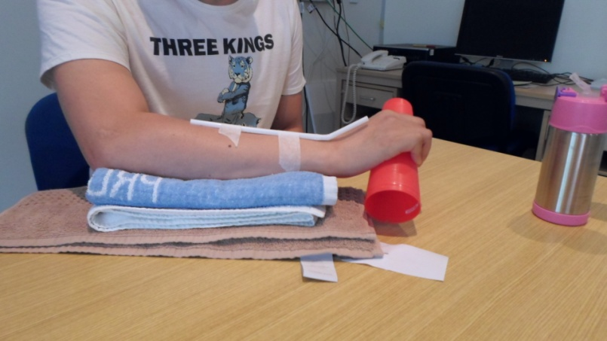  Total reps: 100 Best trial: 30 secs |  | (sec)  40, 39, 39, 38, 37, 35, 32, 31, 31, 30
10-15 MINS: Plan home Assignments: Reflect on your goals – What 10 tasks will you complete tonight that involve using your more-affected hand/arm?
More challenging tasks that I will perform tonight (with mitt on):
1 EG turning a light switch off and on 2 EG opening the fridge door 3 EG using my phone to call my sister 4 EG typing my password on my computer 5 EG using the remote control

Easier Tasks that I will perform tonight (with mitt on):
1 EG wrist extension exercises 2 EG wiping the bench after dinner 3 EG use the tap to fill the dogs water bowl 4 EG move the cushions off my bed 5 EG take my socks off

Timed Trial no :  Description/parameters of task:  Coaching: |  |  | 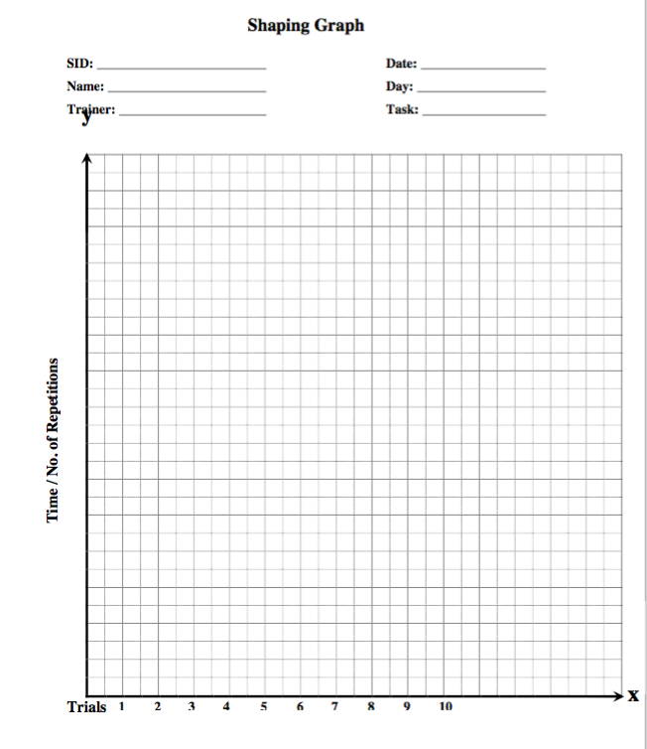
Trial Number (30 sec trial) | No of reps achieved | Comments/ shaping
1 |  | Progressions:
2
3
4
5
6
7
8
9
10
 | Total reps= | Average number of reps =  Target reps for next trial =
15
Day : : <<Insert day and date>>: Home Assignments
Home Assignment Record (please wear constraint for minimum of 1 hour at home each day, while completing various tasks involving your arm and hand)
Task | Time spent doing task | No. of reps achieved
EG held the remote and changed the channels | EG 5 minutes | EG picked up the remote and changed the channels 10 times
EG stacked the dishwasher | EG 20 minutes | EG 12 cups, 16 pieces of cutlery, 6 dinner plates, 4 bowls
EG used my iPAD – play 4 pictures 1 word | EG 20 minutes | EG solved 20 puzzles – typed 20 words.

16
Day 10: <<Insert Day and Date>>:
Brainstorm some tasks that you will complete at home now when the program concludes.
What can you do to continue you progress at home and in everyday tasks?
Tasks:

Follow Up Measures

Measure | One Month Follow up |  | Comments
 | Date | Score

9HPT

Motor Assessment Scale

(6)

(7)

(8)

Box and Block Test
Motor Activity Log  AoU  QoM |  |  | Completed? Y / N  Attached? Y / N
Canadian Occupational Performance Measure (COPM) |  |  | Completed? Y / N  Attached? Y / N

Shaping/ Timed Trial Task: CHINESE STRESS BALLS

Task Description | The person holds two metal Chinese Stress Balls (ie they don’t need to pick them up as part of the 30 secs). Rotate the balls once in the palm of their hand (ie one rotation). There will be a natural ‘right’ direction for the rotation, which is in towards the palm, from the thumb side. Use thumb and index finger to move the balls. The thumb moves the balls across the palm, via flexion and conjunct rotation. The index finger usually keeps the balls separated; try to not let the balls touch.  Hold hand over a towel or cloth so that if the metal balls roll out of their hand, they don’t immediately roll onto the floor and disappear.
Shaping progressions | Direction: Rotate in opposite direction (much harder )  Size of the object: use smaller can initially, then wider /bigger can
Feedback Parameters | Number of reps: Number of rotations in 30 seconds  Time: time taken to rotate balls 5 times (decide what is a realistic goal in 30 or 45 seconds)
Movements to be encouraged | Shoulder: Forward flexion with external rotation – some elbow flexion too  Wrist: Supination and extension  Thumb: Abduction & conjunct rotation. Some extension also.  Fingers: Flexion and conjunct rotation of all fingers, conjunct rotation

Acknowledgement: Adapted from documentation provided by Prof Dave Morris , University of Alabama at Birmingham, at CIMT training workshop, Sydney, Nov 2015

Shaping/ Timed Trial Task: COCKTAIL STICKS

Task Description | Place the empty container of cocktail sticks in front of the person, close to the edge of the table, on a non-slip mat. Tip all of the sticks onto the table. Pick up sticks one by one, between INDEX and MIDDLE fingers and THUMB, using pincer grip. Place into the small (or larger) hole.
Shaping progressions | Distance: The container can be moved farther away to challenge elbow extension or shoulder flexion.  Height: Container can be placed in a ledge (eg shoe box lid) or box to increase shoulder flexion and external rotation.  Size of the holes: use largest hole initially can initially, then smaller holes.
Feedback Parameters | Number of reps: Number of sticks placed in the container in 30 seconds.  Time: time taken to place 5 sticks in container (decide what is a realistic goal in 30 or 45 seconds).
Movements to be encouraged | Shoulder: Forward flexion with external rotation  Elbow: Flexion  Wrist/Forearm: Pronation; wrist flexion and extension  Thumb: Adduction, flexion & conjunct rotation.  Fingers: Flexion and conjunct rotation (opposition) of all fingers with thumb
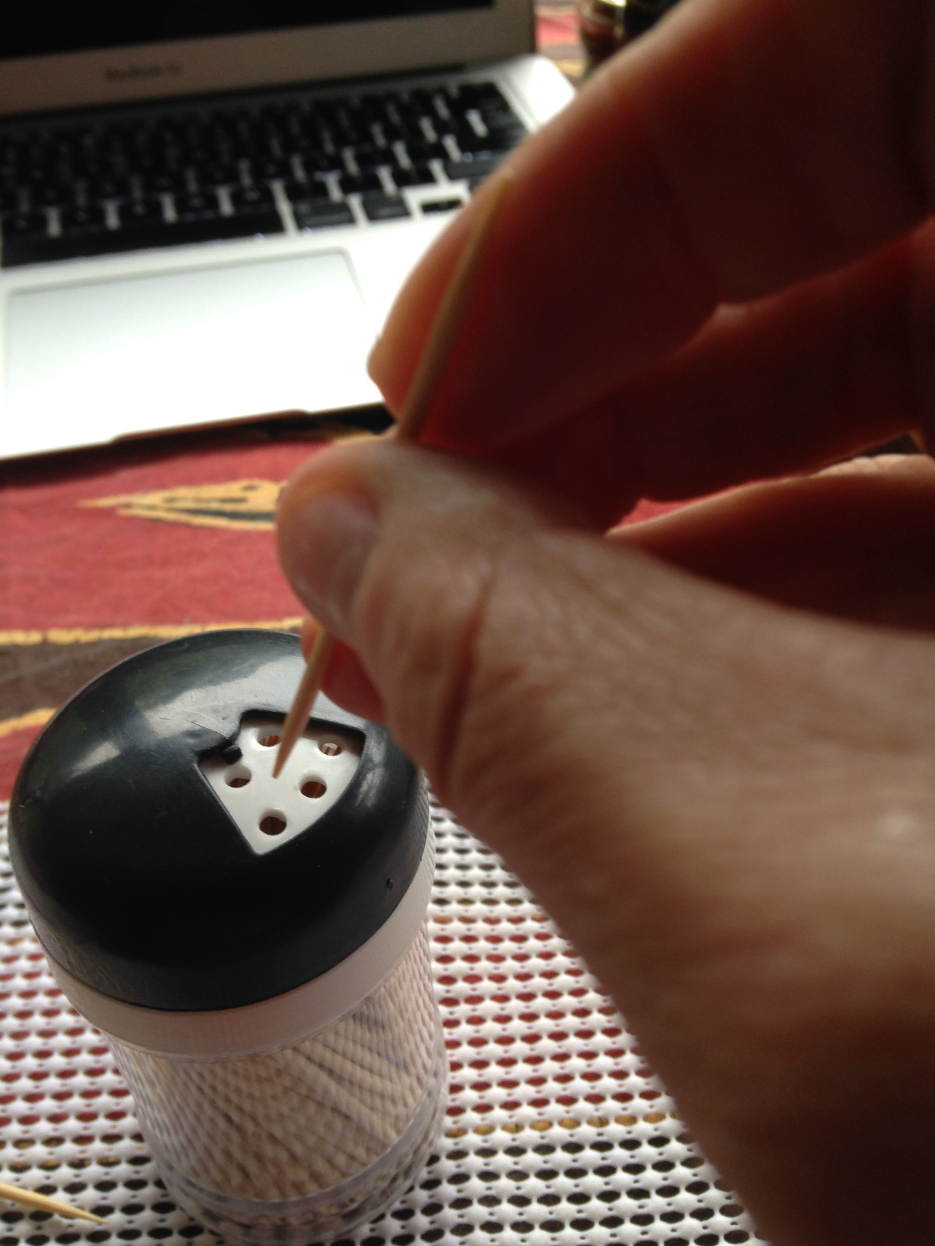
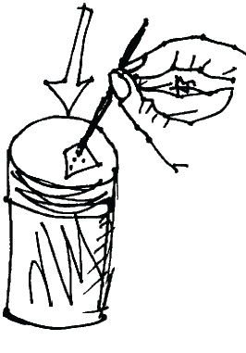

Acknowledgement: Adapted from documentation provided by Prof Dave Morris , University of Alabama at Birmingham, at CIMT training workshop, Sydney, Nov 2015

Shaping/ Timed Trial Task: PLAYING CARDS
Task Description | Pack of cards are placed directly in front on the table. The person is asked to reach forward and turn the cards over, one by one and place them to the right or left. Specific information is provided about HOW to turn the cards over, based on the person’s available movement/ missing components. The aim is to minimise compensations, and optimise quality movement.  Use THUMB under underneath the cards to lift, with INDEX (and MIDDLE) finger on top. Turn card over and LIFT to establish a new ‘pile’ to the right or left.
Shaping progressions | Distance: Start with all cards close to edge of table (within 1-2 cm) and turn over – make task more challenging by asking the person to lift and move cards further over (eg 5cm, 10cm – mark with rule and tape) or place towards the back of the table  Size of the object: use smaller cards initially, then large cards  Height: Start with cards on table, then increase height by placing on small ledge (eg lid of shoebox, upturned tray or book).  Sitting v Standing: If a person has poor shoulder control (transport) start the task in standing to decrease effort. Progress to sitting on high chair or use low table
Feedback Parameters | Number of reps: Number of cards turned in 30 seconds  Time: time taken to turn 3 or 5 cards (decide what is realistic goal in 30 or 45 seconds)
Movements to be encouraged | Shoulder: Forward flexion with external rotation (NB they will need some abduction and internal rotation when picking up cards)  Wrist: Pronation then supination and extension  Thumb: Abduction & conjunct rotation, flexion when lifting cards  Fingers: Pads or side of fingers in contact with cards, MCP flexion and IP flexion, followed by extension/release
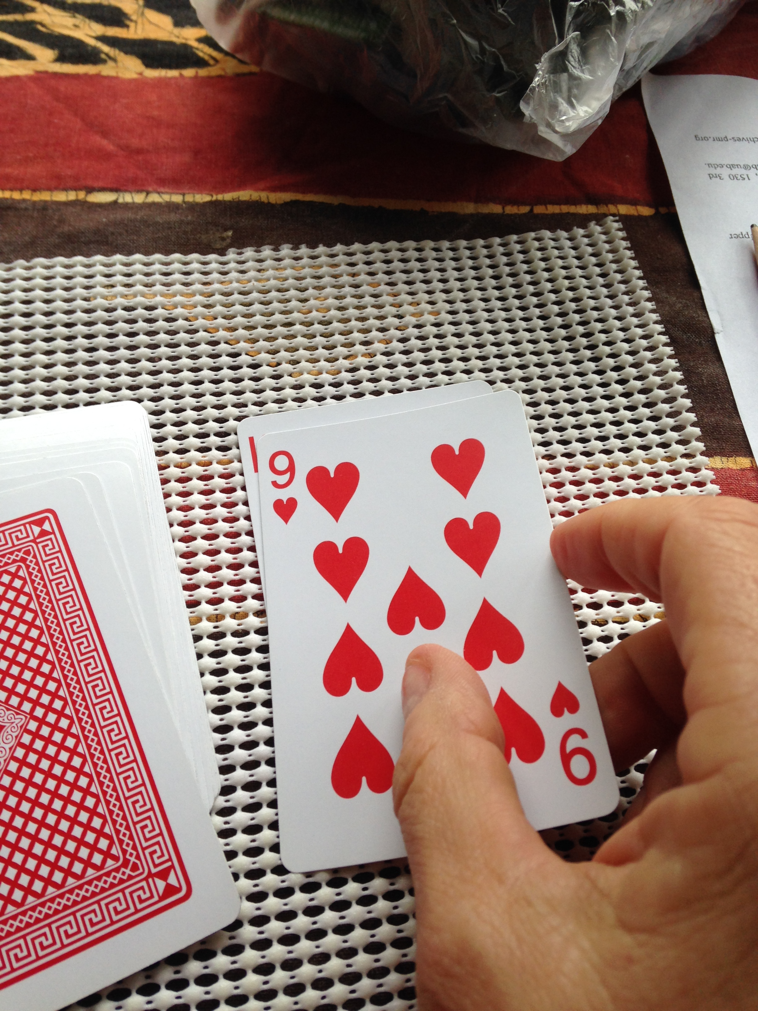
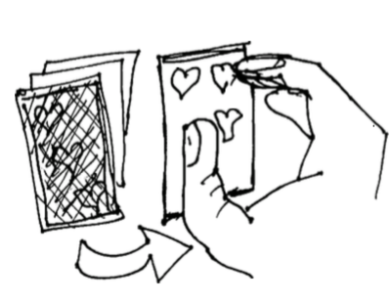

Acknowledgement: Adapted from documentation provided by Prof Dave Morris , University of Alabama at Birmingham, at CIMT training workshop, Sydney, Nov 2015
Shaping/ Timed Trial Task: ELASTIC BANDS AROUND CAN
Task Description | Small can (eg baked beans) is placed on a non-slip mat, along with up to 15 large elastic bands. These items are placed directly in front on the table – close to the edge, with elastic bands immediately beside the can. The person is asked to reach forward, pick up one elastic band at a time, and place the bands around the can. The therapist may need to hold the can to stop it moving, Specific information is provided about HOW to pick up, and stretch the elastics based on the person’s available movement/ missing components. The aim is to minimise compensations, and optimise quality movement.  Use thumb and fingers fingers to pick up elastics, place 4 digits [adducted] and thumb inside the elastic, then stretch open and place elastic band over the can.
Shaping progressions | Distance: Start with elastics close to edge of table (within 1-2 cm) then make task more challenging by asking the person to reach further forwards or to side (eg 5cm, 10cm – mark with ruler and tape) or place the can further away, towards the back of the table  Size of the object: use smaller can initially, then wider /bigger can  Height: Start with can on the table, then increase height by placing on small ledge (eg lid of shoebox, upturned tray or book).  Sitting v Standing: If a person has poor shoulder control (transport) start the task in standing to decrease effort. Progress to sitting on high chair or use low table
Feedback Parameters | Number of reps: Number of elastic bands on can after 30 seconds  Time: time taken to place 2 or 3 elastic bands onto can (decide what is a realistic goal in 30 or 45 seconds)
Movements to be encouraged | Shoulder: Forward flexion with external rotation (NB but they will need some abduction and internal rotation initially for this task)  Wrist: Pronation then supination and extension  Thumb: Abduction & conjunct rotation.  Fingers: Adduction initially, then abduction and extension, MCP and IP flexion initially, followed by extension
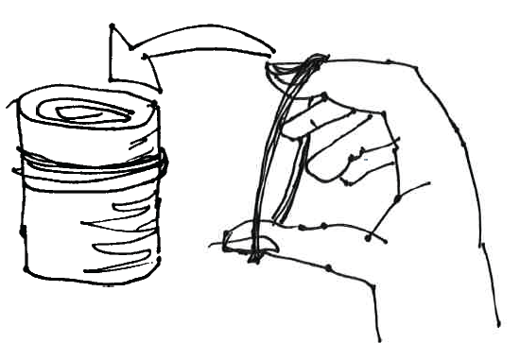
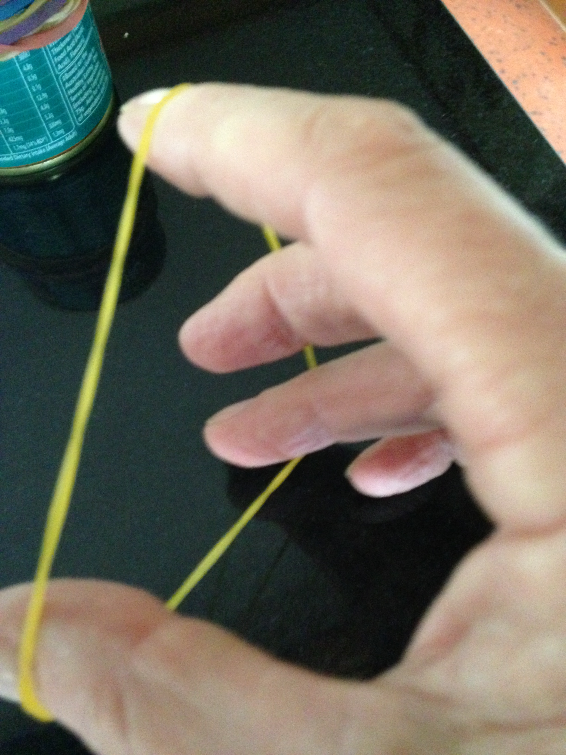

Acknowledgement: Adapted from documentation provided by Prof Dave Morris , University of Alabama at Birmingham, at CIMT training workshop, Sydney, Nov 2015

